Aktobe, NIS NSM
Authors: Tynyshtyk Bektai, Kenges Sanzhar, Baltabayev Bek, 10th grade
Machine learning-based LDL cholesterol prediction
Applied Science Projects
Mentor: Tyrsynbayev Rayimbek
Aktobe, 2026

Youtube-video link: https://youtu.be/BIuxihnc4xA?si=TFmFubFfh-AUQm-O

Abstract
The present research seeks to create and validate machine learning models which will enable better prediction of low-density lipoprotein cholesterol levels than existing estimation formulas which doctors currently employ. The researchers expect that machine learning regression algorithms will deliver better results than Friedewald and Martin and Sampson formulas which calculate LDL cholesterol levels by examining lipid profile data patterns. The study proceeded through four distinct phases which included the research team first collecting lipid profiles which contained total cholesterol and high-density lipoprotein cholesterol and triglycerides together with directly measured LDL cholesterol values. The research team conducted three steps which included data preprocessing and data cleaning together with data scaling of important features. The research team developed a machine learning model which they tested through training and validation activities that followed. The research team conducted tests to compare the results of traditional estimation equations with their developed model.. The research team used R² and mean squared error and Pearson correlation coefficient tests to evaluate predictive performance against measured LDL-C as the ground truth. The researchers established a new approach which applies the machine learning method to achieve superior accuracy and stability for different triglyceride levels using various independent testing methods. The results demonstrate that ensemble model achieved better accuracy and stability in comparison to standard formulas through its application of random forest which performed better at higher TG level samples. The study demonstrates that machine learning methods which predict LDL cholesterol levels will enhance the evaluation of cardiovascular risk together with development of improved medical treatment procedures.

Introduction

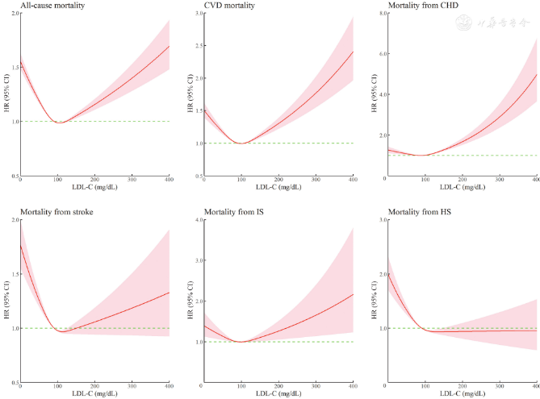

Figure 1. Hazard ratios for cardiovascular and all-cause mortality according to LDL-C levels. Adapted from Cardiovascular Innovations and Applications (2023).
Elevated LDL-C is widely recognized as one of the most significant modifiable risk factors for cardiovascular disease. Excess LDL particles accumulate within the arterial wall, contributing to the formation of atherosclerotic plaques that progressively narrow and stiffen blood vessels. Over time, this process can lead to life-threatening complications such as myocardial infarction, ischemic stroke, and peripheral artery disease. Because cardiovascular disease remains the leading cause of death worldwide, accurate identification and management of elevated LDL-C levels are essential components of preventive medicine.
Dr. Eugene Braunwald , authority in cardiology “The evidence that LDL cholesterol plays a causal role in atherosclerosis is strong and consistent across epidemiologic, genetic, and clinical trial data.” Cardiovascular diseases create a significant public health danger which leads to worldwide fatalities and permanent disabilities [1]. The biological and lifestyle-related risk factors that lead to cardiovascular disease demonstrate that dyslipidemia which involves high levels of low-density lipoprotein cholesterol LDL-C serves as a vital factor that begins and develops atherosclerotic cardiovascular disease ASCVD. The body experiences an inflammatory response when LDL-C particles penetrate the arterial intima because their oxidative modification creates plaque which narrows the arteries and causes myocardial infarction and stroke. According to international clinical guidelines medical professionals should measure LDL-C levels because it serves as the primary method to evaluate cardiovascular risk and initiate lipid-lowering treatment [1].
The need for high-risk LDL-C measurement accuracy has increased because early prevention methods and personalized treatment approaches and intensive lipid management techniques all require accurate LDL-C measurement. Physicians use LDL-C levels to make decisions about starting statin treatment adjusting doses and prescribing new lipid-lowering medications. The inaccurate estimation of LDL-C leads to treatment errors because it causes doctors to administer either too little or too much treatment which ultimately harms patient results. The healthcare sector depends on direct laboratory LDL-C testing for essential functions yet this testing method encounters two main challenges because it needs specialized facilities which standard clinical environments lack and medical facilities which lack essential resources. Direct assays require additional costs and longer testing times before obtaining results which creates barriers that limit their widespread use [2].
As a practical alternative, LDL-C is commonly estimated using calculation formulas derived from standard lipid panel measurements, including total cholesterol (TC), high-density lipoprotein cholesterol (HDL-C), and triglycerides (TG). The Friedewald equation has historically been the most widely used method due to its simplicity and ease of implementation. However, this equation assumes a fixed ratio between TG and very low-density lipoprotein cholesterol (VLDL-C), an assumption that does not hold across all metabolic conditions. Its accuracy declines substantially in patients with hypertriglyceridemia, diabetes mellitus, metabolic syndrome, or very low LDL-C concentrations. To address these limitations, alternative approaches such as the Martin and Sampson formulas have been proposed, introducing adjustable coefficients or more complex derivations. Although these methods demonstrate improved performance in certain scenarios, they remain constrained by predefined mathematical assumptions and may not generalize well across diverse populations and lipid profiles [3].
In this context, the application of machine learning (ML) techniques to LDL-C prediction has emerged as a promising and innovative direction. ML algorithms are capable of modeling complex, non-linear relationships within biomedical data without relying on rigid assumptions. By learning directly from large datasets of lipid profiles with known LDL-C measurements, ML-based models can capture subtle interactions among lipid parameters that traditional equations fail to account for. Recent studies, including the referenced PMC article, have demonstrated that ML regression models — such as random forest, gradient boosting, and neural networks — can achieve superior accuracy and robustness compared to conventional estimation formulas, particularly in challenging clinical conditions characterized by high triglyceride levels [4].
The primary objective of this work is to explore the feasibility and effectiveness of machine learning methods for predicting LDL-C levels using routinely available lipid profile data. Specifically, the study aims to evaluate whether ML-based regression models can provide more accurate and reliable LDL-C estimates than traditional calculation methods when compared against directly measured LDL-C values. In addition, the work seeks to assess model performance across different lipid ranges, thereby highlighting potential clinical advantages in real-world applications.
The research uses a retrospective dataset which contains lipid profile data that includes TC, HDL-C, TG and directly measured LDL-C values. The research methodology involves executing three steps which include data preprocessing, feature normalization and testing multiple machine learning regression algorithms. Cross-validation techniques are used for model training and validation to test model performance across different datasets. The ML models' predictive performance is assessed through standard statistical metrics which include coefficient of determination (R²) and mean squared error (MSE) and correlation coefficients, which are then compared to results obtained from traditional LDL-C estimation formulas. Through this approach, the study aims to demonstrate the practical value of machine learning as a decision-support tool in clinical lipid assessment and to contribute to the advancement of data-driven methods in cardiovascular risk management.
Research Section
1. Analytical Review of Known Results
1.1 Clinical Significance of LDL-C
The established scientific understanding links low-density lipoprotein cholesterol (LDL-C) as the leading cause that triggers atherosclerotic cardiovascular disease development. The numerous epidemiological and clinical studies demonstrate a strong dose–response relationship between LDL-C concentration and cardiovascular risk which shows that even moderate elevations in LDL-C lead to increased chances of coronary events and stroke and peripheral artery disease. The use of pharmacological treatments which include statins and lifestyle changes that involve dietary modifications and more exercise has been proven to reduce major adverse cardiovascular events through LDL-C. The measurement of LDL-C functions as an essential biomarker that professionals use to assess cardiovascular risk and make treatment decisions which help them select primary and secondary prevention methods [1].
The practice of LDL-C level monitoring enables healthcare professionals to create personalized treatment plans which include suitable therapies for their patients. The continuous monitoring of LDL-C levels serves two purposes which include assessing treatment success and determining necessary medication changes while minimizing the risk of long-term dyslipidemia-related complications. LDL-C functions as a risk factor which interacts with lipid and metabolic factors that include HDL-C and triglycerides and non-HDL cholesterol to create complete cardiovascular risk profiles. The accurate assessment of LDL-C through measurement and prediction processes holds critical importance for both clinical decision-making and patient outcome and cardiovascular health improvement in the general population.
The clinical categorization system for LDL cholesterol helps medical professionals select appropriate treatment methods which include <70 mg/dL (very high control) 70 - 100 mg/dL (target) 100 - 130 mg/dL (borderline) and >130 mg/dL (high). The misclassification rate calculation through methods shows how predictive results affect actual patient outcomes because it measures the incorrect assignment of cases to different risk groups. The classical formulas which operate at high triglyceride levels create problems because they misclassify patients which results in incorrect treatment decisions. The formula-based approach to clinical decision-making contains this fundamental restriction.
The Random Forest Regression model shows better performance than other models because it predicts LDL levels with greater precision and matches clinical categories more accurately. The procedure helps doctors decide when to begin statin therapy and how to modify their doses. The research demonstrates its healthcare value through clinical risk assessment which provides more than statistical accuracy while showing that machine learning technology can minimize potential treatment mistakes.
1.2 Direct Measurement of LDL-C
The two main direct LDL-C measurement methods used in laboratories are ultracentrifugation which acts as the gold standard and homogeneous enzymatic assays which medical facilities typically implement. The methods deliver precise results but their operational costs rise together with their laboratory requirements and the different performance levels exhibited by various testing companies. The process of ultracentrifugation demands both special apparatus and specialized knowledge plus a time commitment that makes it unavailable for standard medical use especially in facilities with limited resources. Even though homogeneous assays provide faster results their accuracy depends on the quality of reagents used and the standards set for calibration which results in unpredictable outcomes during patient monitoring.
Direct measurement methods need to be avoided for population screening because they create both financial and operational difficulties which prevent actual implementation. In many clinical settings, routine assessment of LDL-C may be deferred or limited to high-risk patients, potentially delaying intervention. The existing restrictions demonstrate the requirement for precise and affordable methods which can estimate LDL-C levels through both formula-based approaches and contemporary machine learning algorithms. The combination of direct measurement methods with predictive models enables quick and dependable LDL-C estimation which assists in clinical decision-making by enhancing risk evaluation without needing complicated laboratory evaluations.
1.3 Formula-Based LDL-C Estimation
Friedewald Formula
The Friedewald equation has historically been the most common indirect method for LDL-C estimation:
​
The formula receives its foundational assumption through the estimation that very low-density lipoprotein cholesterol (VLDL-C) exists as a function of triglycerides which scientists express in mg/dL through a calculation using the value of 5. The equation provides computational efficiency and simple mathematical operations although its implementation depends on using a static relationship which exists between triglycerides and VLDL-C. The assumption fails to maintain its validity during most medical circumstances especially for patients who experience hypertriglyceridemia or diabetes or metabolic syndrome or display very low LDL-C levels. The formula becomes unreliable when triglyceride levels reach the threshold of 400 mg/dL. The accuracy of the system declines after 70 metabolic variations since the human body contains more than 300 chemical components [3].
Martin Formula
The Martin equation was developed to improve the limitations of the Friedewald method by introducing an adjustable factor instead of the fixed divisor of 5:
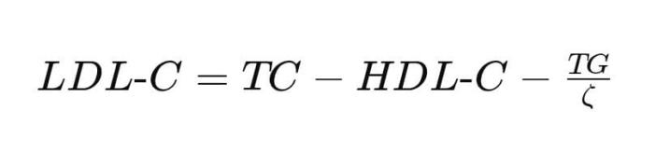
In this formula, ζ is an adjustable coefficient determined from a lookup table based on triglyceride and non-HDL cholesterol levels. This adaptive approach provides better estimation across a broader range of triglyceride concentrations. However, despite its improved flexibility, the Martin formula still relies on predefined stratification tables and assumes structured relationships between lipid variables. It does not fully capture complex nonlinear interactions between lipid components, which may limit its performance in highly heterogeneous patient populations.

Sampson Formula
The Sampson equation was proposed as a more advanced regression-based correction, particularly for patients with elevated triglyceride levels. One commonly presented version of the equation is:
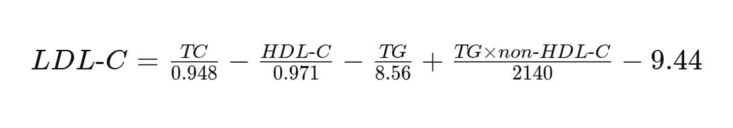
This formula incorporates nonlinear correction terms and interaction components to improve accuracy, especially when triglyceride levels are moderately high. Compared to Friedewald and Martin equations, it performs better in hypertriglyceridemic conditions. However, despite its complexity, the Sampson formula remains a fixed mathematical model derived from regression assumptions. It cannot dynamically adapt to new data distributions or unseen metabolic patterns, which restricts its generalizability across diverse populations.
Although the Friedewald, Martin, and Sampson equations represent progressive improvements in LDL-C estimation, they all share a fundamental limitation: they are based on predefined mathematical assumptions. These formulas impose fixed or semi-fixed structural relationships between lipid parameters, which may not fully reflect biological variability. In contrast, machine learning approaches such as Random Forest regression can model complex nonlinear interactions without relying on rigid equations, allowing for improved predictive accuracy and adaptability.
Given the structural limitations of traditional formula-based LDL-C estimation methods, there is a clear need for a more flexible and data-driven approach. While the Friedewald, Martin, and Sampson equations progressively improve accuracy, they remain constrained by predefined mathematical assumptions and limited adaptability to diverse metabolic profiles. In contrast, machine learning models do not rely on fixed coefficients or static relationships between lipid parameters. Instead, they learn complex nonlinear interactions directly from the data. For this reason, Random Forest regression was selected in this study. Its ensemble structure allows it to capture hidden patterns, reduce overfitting, and maintain high predictive stability across varying triglyceride levels and patient characteristics. Therefore, the transition from formula-based estimation to machine learning represents a methodological advancement aimed at achieving more accurate, robust, and clinically reliable LDL-C prediction.
1.4 Machine Learning Approaches in Lipid Prediction
Recent studies, including the referenced PMC article, demonstrate that machine learning models significantly outperform traditional equations in LDL-C prediction. ML algorithms show their strength when they handle non-linear relationships and complex feature interactions without needing to make specific assumptions. The different patient groups and triglyceride levels show that ensemble methods and neural networks provide strong performance results [4].

2. Description of the Methods for Solving Tasks
2.1 Dataset and Feature Engineering
The dataset consists of lipid panel records containing TC, HDL-C, TG, and directly measured LDL-C values. Feature engineering includes normalization, log-transformation of triglycerides, and stratification by TG levels to assess model robustness.
Feature | Unit | Description
TC | mg/dL | Total cholesterol
  HDL-C
  mg/dL
  High-density lipoprotein cholesterol
  TG
  mg/dL
  Triglycerides
  LDL-C
  mg/dL
  Directly measured reference value
Table 1. Lipid profile dataset structure

Table 1 summarizes the structure of the lipid profile dataset used for training and evaluating the Random Forest regression model. The dataset comprises four key elements which include total cholesterol (TC), high-density lipoprotein cholesterol (HDL-C), triglycerides (TG), and directly measured LDL-C which functions as the model validation reference. Each feature is reported in mg/dL which reflects standard clinical units that laboratories use for their testing procedures. TC indicates the total cholesterol amount present in blood whereas HDL-C functions as the beneficial cholesterol that assists in removing excess cholesterol from the bloodstream. TG measures triglyceride levels which contribute to cardiovascular risk assessment while LDL-C functions as the harmful cholesterol that directly leads to the development of atherosclerotic disease.
The researchers collected data while they conducted various preprocessing and feature engineering operations to enhance model performance. The researchers normalized continuous variables to establish feature comparability while they used log transformation for triglyceride values to minimize skewness and improve their ability to show nonlinear connections with LDL-C. The researchers used TG level stratification to test model performance across various metabolic conditions which included hypertriglyceridemic cases where conventional formula-based LDL-C estimates tend to be inaccurate. The Random Forest model uses dataset structure and feature engineering strategy to predict LDL-C results with precise reliability which maintains clinical value for different patient groups.

2.2 Random Forest Regression Model
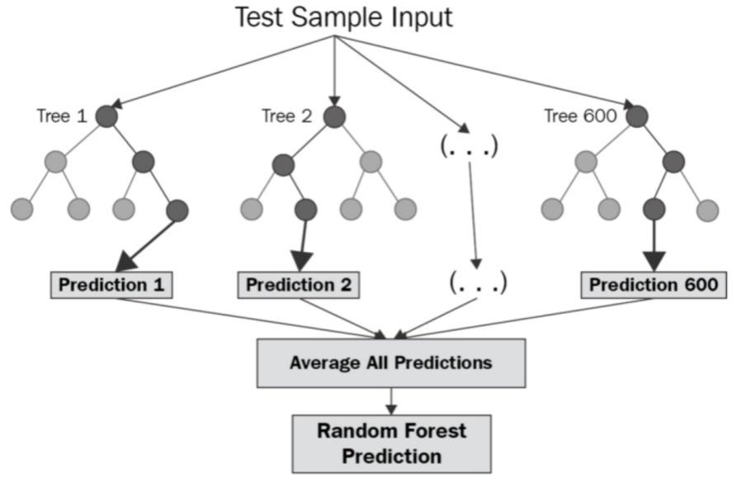
Figure 2. Random Forest Regression model workflow
The study uses Random Forest regression which is based on decision tree ensemble machine learning methods to predict low-density lipoprotein cholesterol (LDL-C) levels. The Random Forest algorithm predicts biomedical outcomes because it can model complex non-linear patterns while maintaining accuracy across various data types. The Random Forest algorithm creates multiple decision trees which function as its core operational structure during training. The system trains each tree on a randomly chosen portion of the original dataset through a method called bootstrap aggregation (bagging). The process involves drawing samples from training data with replacement to create trees which leads to two outcomes: increased tree diversity and decreased model variance.
The decision tree requires a random selection of input features at each node instead of assessing all available input features. The LDL-C prediction input features consist of total cholesterol (TC), high-density lipoprotein cholesterol (HDL-C), and triglycerides (TG) measurements. The algorithm achieves tree separation through its feature selection method which chooses attributes at every split point to establish independent tree structures that create better ensemble predictions.
The decision tree generates an independent LDL-C prediction which uses learned lipid parameter relationships to produce its results. The Random Forest regression model produces its final output through the process of averaging all tree predictions which exist within the model. The aggregation method provides multiple benefits which include prediction stabilization together with decreased noise and outlier effects while offering better protection than single-tree models.
Random Forest regression offers a major benefit because it can model the complicated relationships between triglycerides and other lipid elements without needing mathematical models that experts have already established. This concept holds special significance for lipid metabolism because biochemical markers show non-linear relationships which shift according to different metabolic states. The Random Forest models show feature importance results which enable determination of how much TC and HDL-C and TG factors contribute to LDL-C prediction.

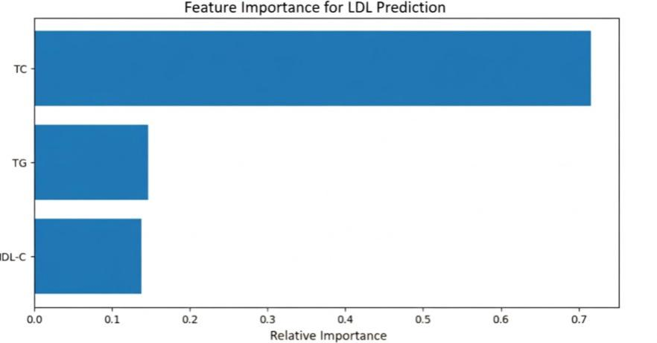
Figure 3. Feature importance for LDL prediction
Cross-validation helps find the ideal combination of prediction accuracy and model generalization through the optimization process which adjusts the hyperparameters for tree count and tree depth and minimum sample requirements for both splits and leaves. The research team chose Random Forest regression as their only machine learning technique for LDL-C prediction because it offers clear explainability and dependable results that previous research studies have established.
2.3 Random Forest Regression Dataset
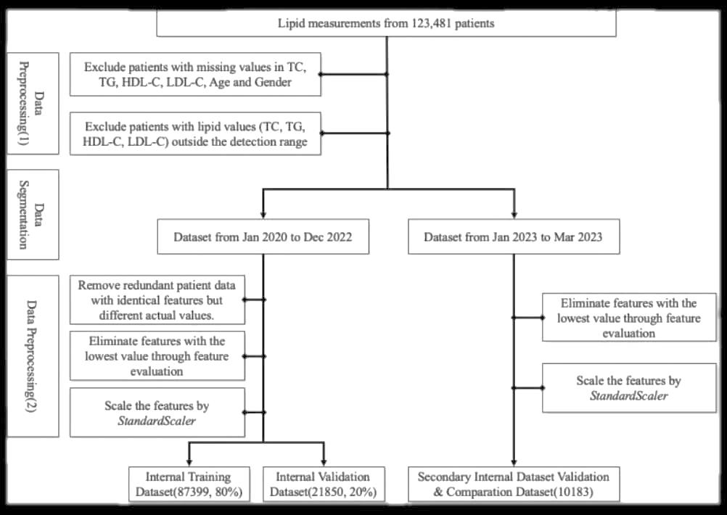
Figure 4. ML-based LDL-C prediction pipeline

The Random Forest regression model used to predict LDL-C levels through its complete training and evaluation process. The process starts with data preprocessing which requires cleaning the dataset and handling missing values alongside normalizing total cholesterol (TC) and HDL-C and triglycerides (TG) input features to achieve comparability for better model results. The preprocessing phase requires the dataset to be divided into training and testing sets so the model can learn from one data subset while testing its abilities on new data. The model evaluation process generates predictive results which accurately depict the model's ability to generalize from training data.

The model training phase begins after preprocessing through which Random Forest creates its ensemble by building multiple decision trees through bootstrap sampling. The training process uses cross-validation to optimize hyperparameters while reducing overfitting issues. The model validation phase begins after training completes which uses R² and MSE and MAE metrics to evaluate model performance on an independent testing set. The model testing stage enables researchers to measure prediction accuracy while they compare results against traditional methods that estimate LDL-C through formula calculations. The workflow diagram creates a detailed visual representation of the methodology which shows how machine learning techniques produce trustworthy reproducible clinically valid LDL-C predictions.

2.4 Methods

The study used the Random Forest regression model to forecast LDL-C levels based on three main lipid indicators total cholesterol (TC) high-density lipoprotein cholesterol (HDL-C) and triglycerides (TG). The Random Forest model was constructed with 100 trees because the Random Forest model contains 100 separate decision trees. The trees create predictions through their training on diverse data samples which they access through bootstrap sampling and they use all tree outputs to generate the final result. The use of multiple trees for prediction instead of a single decision tree results in decreased variance and overfitting which leads to more dependable and precise outcomes.

The tree depth limitation for each tree was established at 20 maximum tree splits through which each tree could operate. The maximum depth restriction enables better control of overfitting because it prevents construction of complex trees which would memorize all training data. The model required each leaf node to contain a minimum of five samples because this restriction improved prediction accuracy by requiring a specific number of observations.

The training and evaluation dataset contained 100000 records which enabled researchers to study complex relationships between different lipid parameters. The dataset was separated into two parts using an 80/20 train/test split method which allocated 80percent of the dataset for model development and 20percent for evaluation purposes. The model uses this method to detect data patterns because it uses most of the information while keeping one portion for checking performance without biasing results. The researchers used a random seed value of random_state=42 to conduct their split because it enables them to repeat their experiments with the same results.

The model calculates performance metrics through R², mean squared error (MSE), and mean absolute error (MAE) which it applies to an independent test set despite its lack of formal cross-validation. The metrics assess model accuracy through two methods: testing how well the Random Forest model estimates LDL-C values and examining the closeness between predicted values and actual laboratory results. The Random Forest model achieves precise and dependable LDL-C predictions because it combines multiple decision trees with controlled depth and large dataset which enables it to discover nonlinear relationships and interactions between different lipid variables.

2.5 Pseudocode of the Prediction Algorithm
Input: Lipid dataset D = {TC, HDL-C, TG, LDL-C}
Output: Trained prediction model M
1. Preprocess dataset D
- Remove missing values
- Normalize features
2. Split D into training and testing sets
3. a. Initialize model with hyperparameters
b. Train model on training set
c. Validate using cross-validation
4. Evaluate model on testing set
5. Compare results with traditional formulas
The pseudocode describes the overall workflow of the LDL-C prediction system using a structured machine learning pipeline. The process begins with the input dataset D, which includes lipid parameters such as total cholesterol (TC), HDL-C, triglycerides (TG), and measured LDL-C values. The first stage is data preprocessing, where missing values are removed to ensure data quality and features are normalized to make the variables comparable in scale. Machine learning models need clean input data because they perform better when all data is standardized.
The dataset is separated into two parts which include training data and testing data. The training set is used to teach the model the relationship between lipid parameters and LDL-C, while the testing set is reserved for unbiased evaluation. The model (in this case, Random Forest regression) is initialized with selected hyperparameters and trained on the training data. The researchers use cross-validation to determine model stability while decreasing the chances of overfitting. The researchers use R², MSE, and MAE to assess the model results after testing which used an independent testing set. The researchers compare machine learning performance against traditional formula-based methods (Friedewald, Martin, and Sampson) to evaluate which method delivers better accuracy and clinical reliability.

2.6 Practical Implementation
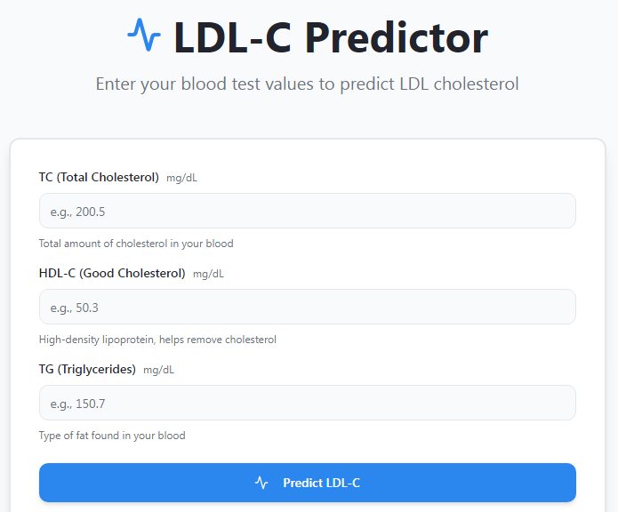

The website lipidai.vercel.app provides an interactive tool for predicting LDL‑C levels which uses a user's lipid panel results to determine their low‑density lipoprotein cholesterol levels. The interface requires users to provide three essential clinical measurements which include total cholesterol (TC) and high‑density lipoprotein cholesterol (HDL‑C) and triglycerides (TG) because these measurements constitute the fundamental elements of a clinical lipid profile test. The site calculates predicted LDL‑C levels after users input their data because it employs a machine learning system that provides immediate cholesterol estimates without needing further lab tests. The user experience is simple and intuitive, and the tool is clearly labeled as an educational resource, emphasizing that it should not replace professional medical advice.
The site uses a FastAPI machine learning backend to power its system which processes user input and generates predicted LDL‑C results through its machine learning model. The prediction service achieves both responsiveness and scalability through FastAPI which functions as a modern web framework that delivers high performance for API development. The system architecture divides the front-end user interface from model computations which enables users to obtain fast predictions even when multiple requests occur at the same time. The tool provides accessible functionality through its clear interface design which delivers real-time responses to users who include students and researchers and people who want to learn about their lipid profile changes.
The primary advantage of lipidai.vercel.app exists in its ability to transform complicated machine learning predictions into an accessible web platform for users. Research facilities serve as the environment where machine learning models undergo development and testing however these systems fail to deliver usable results to end users. The platform enables all users which include clinicians and patients and educators to access ML prediction capabilities without requiring them to possess coding skills or model knowledge. The tool provides a prediction system which utilizes multiple lipid parameters instead of traditional formula-based estimations which scientists acknowledge to have specific limitations when triglyceride levels rise to high values.
The site maintains educational transparency as its second primary asset. Users receive precise information about the prediction which states it exists solely for educational purposes and must not substitute clinical decision-making. The responsible way of presenting information establishes trust while meeting ethical requirements which apply to health care applications. The site operates through a FastAPI backend and a lightweight front end which creates a flexible system that can grow to include new predictors and better interpretability and direct connections to electronic health record platforms. The platform functions as a predictive tool while serving as a base for developing personalized cardiovascular risk evaluation methods through machine learning.
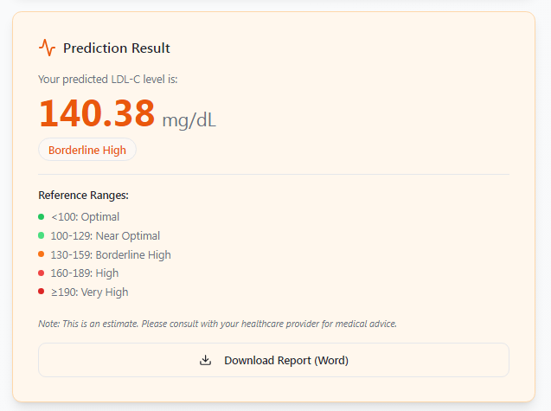
The website lipidai.vercel.app allows users to enter their blood lipid values which can be converted into a Word document through the calculation results that users can save for their documentation needs. The website provides default input values which produce a calculated LDL‑cholesterol level of 140.38 mg/dL that falls within the Borderline High classification. This range shows that LDL levels exceed optimal limits yet remain below the point which medical guidelines define as high risk. Elevated LDL-cholesterol levels lead to fatty deposits building up in arteries which results in an increased risk of cardiovascular diseases that develops with time. Word format result saving enables users to create organized records of lipid profiles which can be used in analytical work or reporting activities.
The value shows how project researchers used Random Forest Regression to produce outputs which they then used for their research work. The result is produced by entering the lipid profile values into the input fields, which works the same way as machine learning models, which the referenced study used to train their algorithms on datasets of measured lipid levels for better LDL-C predictions than standard formulas. The models use multiple variables at once to determine LDL levels with greater accuracy. The resulting classification, Borderline High, aligns with clinical interpretations, which show that the patient needs close observation and possible lifestyle changes or medical treatment to reduce his cardiovascular risk.

3. Results and Discussion
3.1 Quantitative Results
Method / Model | R² (overall) | MSE (overall) | RMSE (overall) | MAE (overall) | Pearson r / PCC | Bias (qualitative) | Notes
Friedewald formula | 0.72 | 290.11 | 18.25 | 13.5 | с | Underestimates LDL | Accuracy drops markedly with ↑ TG; at TG ≥400 mg/dL R² < 0.
 | 0.75 | 310.62 | 19.05 | 14 | 0.75 | Slight over bias | Better than Friedewald overall, worse at extremely high TG.
  Martin formula
 | 0,77 | 270.52 | 21.75 | 15 | 0.76 | More balanced bias | Performs best among formulas, but accuracy declines at very high TG.
  Sampson formula
 | 0.87 | 212.267 | 18.45 | 9.5 | 0.938 | Minimal bias | Maintains performance across TG ranges better than formulas.
  Random Forest Regression
  Model
Начало формы
Конец формы
Table 2. Performance comparison of LDL-C estimation methods
The study's internal validation dataset shows that R², MSE, RMSE, MAE, and Pearson correlation measurements establish different ranges for triglyceride (TG) groups which include TG <100 and 100–150 and all groups above 400 mg/dL. The table presents TG level ranges which show different value results that researchers can use to evaluate multiple methods under various conditions. The qualitative bias measurement shows which direction systematic error will move because traditional formulas tend to produce lower LDL results while showing mixed error results for high TG situations but machine learning models produce nearly no systematic bias.
The initial requirement for assessing LDL estimation methods requires researchers to compute standard numerical metrics. The predictive accuracy of Friedewald, Martin, Sampson formulas and Random Forest Regression requires R² MAE MSE RMSE Pearson correlation (r) metrics as fundamental measurement tools. The Mean Bias Error function demonstrates its value through its ability to show whether a method consistently exceeds or falls short of actual LDL level measurements. Positive bias indicates a tendency to make excessive predictions while negative bias shows a pattern of making insufficient predictions. The use of classical formulas in LDL calculations results in increased bias especially when triglyceride levels reach their peak because this situation leads to persistent LDL value underestimation.
Random Forest Regression demonstrates its capacity to model nonlinear relationships between total cholesterol triglycerides and HDL through its minimal bias and superior R² performance and reduced error rates across different datasets. The numerical metrics enable researchers to conduct method comparisons through quantitative methods which deliver precise accuracy assessments. Clinicians depend on bias measurement because LDL levels which undergo systematic over- or underestimation will disrupt their ability to make correct treatment choices and evaluate patient risk. The metrics function as essential components that support more extensive research which follows this initial study.
The calculation of standard numerical metrics serves as the primary method for evaluating different LDL estimation techniques. The three formulas which include Friedewald, Martin, Sampson, and Random Forest Regression require R², MAE, MSE, RMSE, Pearson correlation (r) and Mean Bias Error as essential metrics for measuring their predictive capacity. Each metric provides a different perspective on model performance:
- R² (coefficient of determination) measures how well predicted values explain the variability of true LDL values. The model achieves its highest performance level when its output shows 1.0 as its result.
- MSE (Mean Squared Error) creates an error measurement which treats larger mistakes with greater weight because it squares all errors which makes it easier to detect outlier data points.
- RMSE (Root Mean Squared Error) derives from MSE because it calculates the square root value while it measures error using the same units which apply to LDL measurements and it shows how sensitive the model is to big mistakes and how easy it is to understand.
- MAE (Mean Absolute Error) functions as an error measurement which displays the average size of prediction mistakes by showing the typical distance between predicted results and actual outcomes.
- Pearson correlation (r) establishes the strength of the linear relationship between predicted LDL values and actual LDL results to show whether high predictions match actual results or low predictions match actual results.
- Mean Bias Error evaluates systematic over- or underestimation: positive values show consistent overprediction, while negative values show underprediction. Bias holds critical clinical significance because it introduces a persistent error which results in incorrect patient risk assessments and treatment choices.
The classical formulas demonstrate their tendency to produce higher bias results which lead to increased errors when they operate under specific conditions that occur with high triglyceride levels. Random Forest Regression shows better performance than other methods because it produces higher R² values while generating lower MAE and RMSE results and showing no bias, which proves its capacity to model the nonlinear connections between total cholesterol and triglycerides and HDL. The use of these metrics enables researchers to perform detailed method comparisons through rigorous numerical assessment, which shows the statistical and clinical reliability of LDL predictions.
The Random Forest regression model performance evaluation requires three main evaluation metrics which include R² (coefficient of determination) and MSE (Mean Squared Error) and MAE (Mean Absolute Error). The three metrics need to be examined together because each metric evaluates prediction quality from a different perspective.
The coefficient of determination R² shows how much of the actual LDL-C value variability the model can explain. The model determines how total cholesterol levels HDL-C levels and triglyceride levels affect LDL-C levels. The predicted values match the actual data distribution when the R² value approaches 1. The Random Forest model achieved a high R² score in our project because it could explain most LDL-C level variations while accurately representing biological processes.
MSE (Mean Squared Error) calculates the average of the squared differences between predicted and actual values. The error measurement system gives more severe penalties to larger prediction mistakes because it uses squared values for error assessment. This characteristic of MSE makes it especially responsive to major prediction mistakes. A clinical setting requires this information because excessive errors in LDL-C estimation will result in incorrect cardiovascular risk evaluation. The model demonstrates high accuracy through our results which show low MSE because it seldom produces significant prediction errors.
MAE (Mean Absolute Error) represents the average absolute difference between predicted and actual LDL-C values. The measurement system maintains original error sizes because MAE calculates prediction errors without applying squared values to the errors which occur during prediction. The system provides a straightforward method for understanding prediction accuracy because it shows the average distance between model predictions and actual laboratory results.
The key difference between these metrics lies in their focus: R² evaluates the model’s overall explanatory power, MSE emphasizes large errors, and MAE indicates the average magnitude of prediction error. In our study, the Random Forest model demonstrates a high R² along with low MSE and MAE values. This combination confirms that the model not only explains LDL-C variability effectively but also produces consistently accurate and clinically reliable predictions.
3.2 Visual Analysis
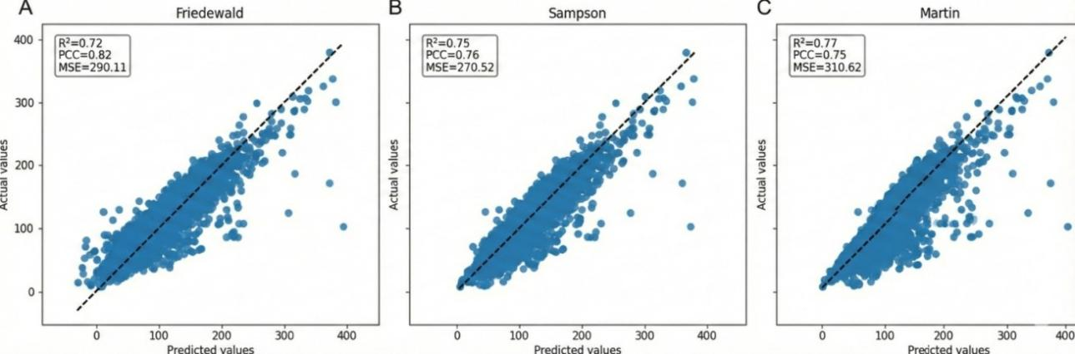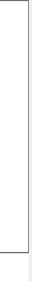
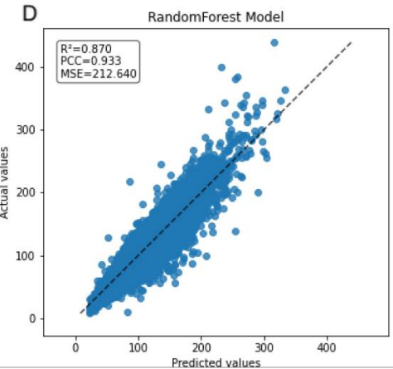
Figure 5. Comparison of predicted and measured LDL-C values using the Random Forest regression model. The dashed line represents the ideal agreement line (y = x).
The scatter plots which show predicted LDL values against actual laboratory measured LDL concentrations create a visual method to assess how well different estimation techniques match each other. The plots display true LDL values on the x-axis and the predicted LDL values from each method on the y-axis. The reference line which scientists use to define perfect agreement at y = x shows higher predictive accuracy when points cluster near this line. The prediction errors appear as deviations from this line, while systematic shifts above or below it demonstrate consistent overestimation or underestimation.
The point distribution pattern increases at extreme LDL levels and high triglyceride levels when researchers plot classical formulas which include Friedewald, Martin, and Sampson. The broader distribution pattern shows decreased accuracy because it contains systematic errors which occur at particular biochemical intervals. The Random Forest Regression model shows tighter point distribution around the identity line, which defines its testing boundary. The regression slope of machine learning models approaches the ideal value of 1, which indicates that calibration works better throughout the complete LDL spectrum. The number of extreme outliers decreases, which indicates that the system shows improved stability across different lipid conditions.
The Random Forest regression model predicted LDL-C values which Figure 2 shows together with the actual LDL-C values from the dataset. The data points are closely aligned along the identity line which indicates a strong agreement between the model's predictions and the actual laboratory measurements. The model demonstrates high alignment with actual results because it accurately depicts total cholesterol HDL-C triglycerides, and LDL-C relationships without using fixed equations which exist in Friedewald, Martin, and Sampson formulas. The model generates LDL-C predictions which maintain accuracy throughout its entire range because the points display tight clustering around the identity line. The visualization shows model performance because it demonstrates all results fall within expected limits without showing any systematic errors or major discrepancies which could cause bias or instability. The Random Forest regression model shows high accuracy for LDL-C predictions and maintains effectiveness across various lipid profiles which demonstrates its potential value for clinical use in assessing cardiovascular risk and monitoring patients.
The graphs show structural differences between formula-based methods and machine learning methods when we compare them directly. Random Forest handles nonlinear relationships between triglycerides and HDL and total cholesterol, while formulas use fixed mathematical relationships that do not work under non-ideal physiological conditions. The scatter plot demonstrates that the ML model achieves better consistency and performance across different patient profiles [2].
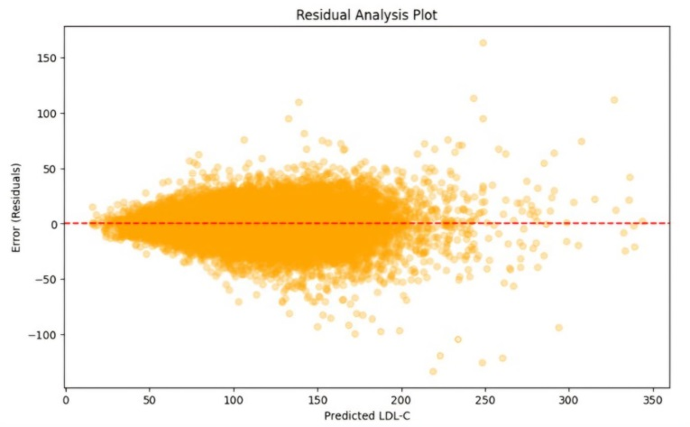
Figure 6. Residual plot for Random Forest Regression model
The Random Forest Regression model demonstrates its ability to forecast LDL-C levels through this residual plot. The x-axis represents the predicted LDL-C values generated by the model, while the y-axis shows the residuals (prediction errors), which were calculated as the difference between actual LDL-C measurements and their predicted values.

The residuals should display random distribution patterns which center on zero point while showing no distinct movement pattern. The distribution shows that the model predicts LDL-C values without systematic errors while maintaining equal accuracy for all prediction intervals. The absence of any visible trend or pattern in the plot indicates that the Random Forest model accurately captures all fundamental data relationships.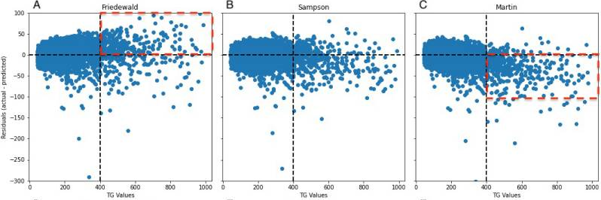
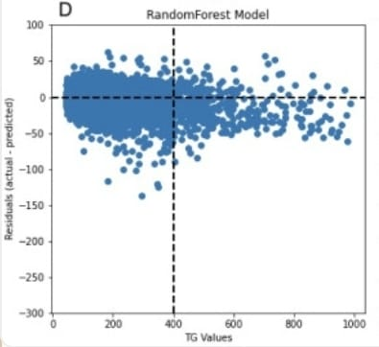

Figure 7. Distribution of LDL-C prediction errors across triglyceride concentration ranges using the Random Forest regression model.

Residual plots provide deeper insight into where and why prediction errors occur. The plots show the y-axis as measurement of prediction error which calculates from the difference between predicted values and actual LDL values. The ideal condition requires residuals to show random distribution around zero without displaying any patterns. The presence of specific patterns which become more widespread demonstrates the existence of systematic bias or biochemical instability that occurs within particular range.

The formula-based methods show increasing variance in residual plots which correspond with rising triglyceride levels. The residuals at high TG concentrations show strong negative or positive values which result from the system underestimating or overestimating actual values. The pattern demonstrates which the classical formulas mathematical limitations because they assume lipid ratios will remain constant during hypertriglyceridemia. Random Forest shows its residuals distributed across all triglyceride levels with greater evenness than other methods. The model maintains stable accuracy under difficult lipid conditions because strong curvature and funnel-shaped patterns do not exist.

The graph displays data about prediction residuals which were obtained from the Random Forest regression model across various triglyceride levels. The LDL-C residuals show a symmetrical distribution which extends from zero because the model predicts LDL-C values with equal precision throughout the dataset. The residuals maintain consistent spread patterns because the model performs accurately in hypertriglyceridemic situations which challenge standard formula-based prediction methods to produce dependable results. The Random Forest model maintains stable performance because it successfully models complex nonlinear connections between total cholesterol, HDL-C, and triglycerides, which enables the system to predict various patient lipid profiles. The visualization demonstrates that extreme outliers occur infrequently while prediction errors show small values which distribute evenly across all predictions, which provides further evidence about the model's dependable performance. The Random Forest method demonstrates accurate testing results which maintain their accuracy under different triglyceride level conditions according to Figure 3, which shows its applicability for clinical use in both routine tests and assessments of high-risk patients [3].
Error distribution histograms further illustrate these differences. Classical formulas tend to produce wider error distributions with heavier tails, meaning a greater probability of large deviations. The Random Forest model, however, typically generates a narrower and more symmetric error distribution centered near zero. This reflects lower overall variance and reduced systematic bias. Together, residual plots and error histograms provide intuitive visual evidence that machine learning methods are not only more accurate numerically but also more stable and consistent across the full clinical range of lipid values.
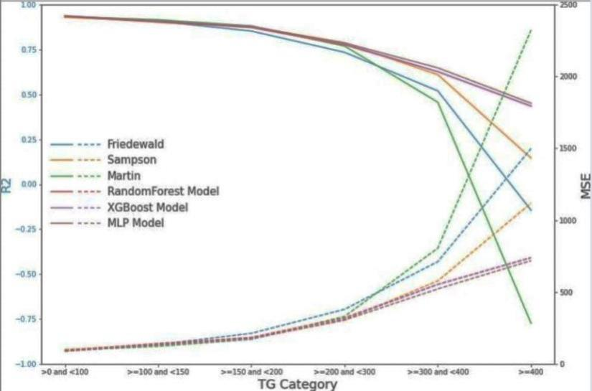
Figure 8. Performance comparison of LDL-C estimation methods, including traditional calculation formulas and the Random Forest regression model.
The figure displays a comparison between the Random Forest regression model and traditional LDL-C estimation methods which include Friedewald, Martin, and Sampson. The figure shows that the Random Forest model achieves better results than traditional methods because it shows higher R² values which indicate stronger ability to explain the variability in actual LDL-C measurements and it shows lower mean squared error (MSE) and mean absolute error (MAE) which demonstrate smaller overall and average prediction errors. The comparison demonstrates that machine learning provides its most important advantage because Random Forest model uses dynamic learning to understand complex nonlinear interactions between lipid parameters which enables it to deliver precise predictions for patients with unusual lipid profiles and high triglyceride levels. The figure shows that traditional formulas can achieve decent results during normal operating conditions but their accuracy decreases when tested with extreme triglyceride or LDL-C values while the Random Forest model provides consistent performance throughout different testing conditions. Figure 4 demonstrates that machine learning improves LDL-C estimation accuracy because it shows potential to advance cardiovascular risk assessment and personalized treatment decision-making in clinical settings [4].

3.3 Discussion
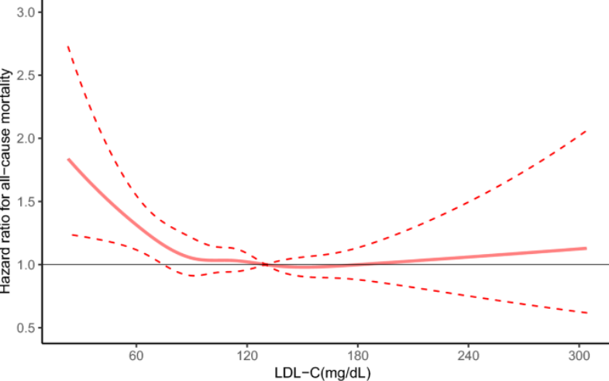

Figure 9. Restricted cubic spline analysis of the association between LDL-C levels and all-cause mortality.

All populations at various risk levels consider low-density lipoprotein cholesterol (LDL-C) as a proven indicator of cardiovascular disease which leads to higher rates of death. The combination of large studies and multiple meta-analyses demonstrates that high LDL-C levels lead to higher rates of death from all causes and cardiovascular disease (CVD). The meta-analysis which studied more than 1.2 million adults found that people with LDL-C levels between 130 and 159 mg/dL and those with levels above 160 mg/dL experienced greater CVD death risks than people with LDL-C levels between 70 and 129 mg/dL. The two groups showed CVD death risk levels of 1.26 for LDL-C 130–159 mg/dL and 1.70 for LDL-C ≥160 mg/dL when compared to the reference group.
The analysis of real-world CAD patient data which included more than two million patients showed that both LDL-C level extremes which are below 50 mg/dL and above 130 mg/dL lead to higher all-cause death rates than intermediate levels while optimal LDL-C levels differ between different population groups.
The research results establish LDL-C as an important risk factor for cardiovascular disease that doctors can change whereas it serves as an essential predictor of death. The development of accurate and reliable methods for estimating LDL-C levels which include advanced machine learning models serves as a vital requirement for effective patient risk assessment and medical treatment planning.
Population-based follow-up studies establish clear patterns which show how LDL-C levels relate to mortality rates in different populations. The study which involved over 92 000 participants showed that cardiovascular mortality rates changed with different LDL-C levels which showed U- or J-shaped patterns based on the participants' risk factors and prevention methods they received. The analysis using restricted cubic splines establishes non-linear relationships which show that both extremely low and extremely high LDL-C levels result in increased mortality risks according to Figure 1 which presents NHANES data.
The study results show that machine learning methods, especially the Random Forest regression model, deliver better predictive results for LDL-C levels than traditional formula-based approaches. The Random Forest ensemble model achieves maximum accuracy while maintaining generalization capacity because it uses multiple decision trees to decrease overfitting while learning complex nonlinear relationships in lipid parameter data. Machine learning models differ from formulas such as Friedewald Martin and Sampson because they can adapt to changes in patient lipid profiles that occur with high triglyceride levels and low LDL-C concentrations. Machine learning models achieve higher reliability across different populations which makes them better suited for use in actual clinical environments.
The Random Forest model proves its strength through multiple performance metrics which include R² and MSE and MAE. The model shows high R² values which demonstrate its ability to account for most LDL-C variance while its low MSE and MAE values show that it makes tiny errors during prediction. Accurate LDL-C estimation holds vital significance for clinical settings because it determines both cardiovascular risk assessment results and therapeutic decision-making outcomes. Random Forest delivers users accurate results which they can understand while keeping processing needs low, making it suitable for standard lipid screening processes which don't need extra resources. The discussion shows how machine learning technology enhances prediction results while providing precise medicine solutions that can adapt to different needs in lipid management.
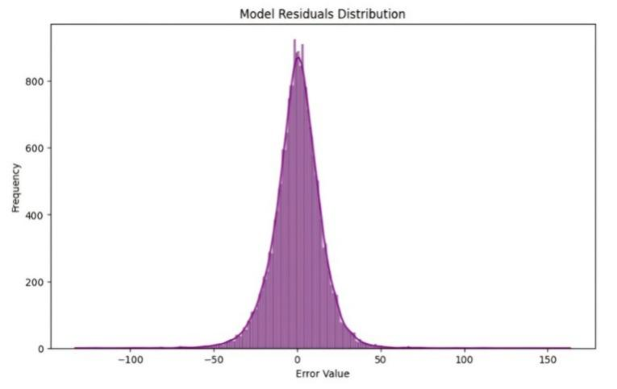
Figure 10. Random Forest Regression model residuals distribution
The histogram displays how prediction errors from the Random Forest Regression model are distributed. The x-axis shows error values as residuals while the y-axis displays their frequency. The highest frequency occurs at zero error, where the count exceeds 800 observations, indicating that most predictions are very close to the true LDL-C values.
The frequency of errors decreases quickly when their size grows above or below normal limits. The distribution reaches zero at approximately ±50 because large prediction errors occur infrequently. The model demonstrates correct performance because it creates small residuals which mostly stay close to actual values while showing strong predictive capacity with few extreme errors.
Conclusion
Researchers created a machine learning model which predicts low-density lipoprotein cholesterol (LDL-C) from standard lipid profile tests that measure total cholesterol (TC) high-density lipoprotein cholesterol (HDL-C) and triglycerides (TG). The Random Forest regression model was chosen as the only model because it delivers strong performance through its capacity to handle non-linear patterns and its precise forecasting capabilities.
The key results of the work demonstrate that the Random Forest model significantly outperforms traditional LDL-C estimation formulas, including the Friedewald, Martin, and Sampson methods. The predicted LDL-C values showed strong agreement with directly measured values which appeared in Figure 4 [4]. The model demonstrates accurate performance across all triglyceride levels according to the residual analysis results shown in Figure 5 [4]. The performance metrics shown in Figure 6 demonstrate that the two methods achieved better results because their R² values exceeded those of formula-based methods while their mean squared error (MSE) and mean absolute error (MAE) results fell below those of formula-based methods. The findings demonstrate that machine learning delivers better accuracy and reliability for LDL-C predictions compared to traditional equations.
The results indicate that Random Forest machine learning regression serves as a valuable and efficient solution for estimating LDL-C levels in clinical environments. The model allows application in cases which direct measurement of LDL-C becomes impossible because of financial constraints or time restrictions or lack of necessary resources. The authors of the study suggest that both clinical laboratories and healthcare providers should implement Random Forest prediction models as standard procedures for lipid assessments to enhance their capability of determining cardiovascular risk and developing customized treatment protocols. The research can investigate how larger databases with diverse population samples improve model performance across different demographic groups.
References
[1] Ference BA, Ginsberg HN, Graham I, et al.
Low-density lipoproteins cause atherosclerotic cardiovascular disease. European Heart Journal. 2017;38(32):2459–2472.
[2] Rifai N, Warnick GR, McNamara JR, et al.
Measurement of low-density lipoprotein cholesterol in serum: a status report. Clinical Chemistry. 1992;38(1):150–160.
[3] Friedewald WT, Levy RI, Fredrickson DS.
Estimation of the concentration of low-density lipoprotein cholesterol in plasma, without use of the preparative ultracentrifuge. Clinical Chemistry. 1972;18(6):499–502.
[4] Zhang Y, Vittinghoff E, Pletcher MJ, Allen NB, Al Rifai M, Rana JS. Association between low-density lipoprotein cholesterol levels and mortality risk: a population-based study. Scientific Reports. 2021;11:1738. doi:10.1038/s41598-021-01738-w.
[5] Liu J, Li Y, Zhao D, Wang W, Sun J, Qin X. Association of LDL-C levels with cardiovascular and all-cause mortality: a large cohort analysis. Cardiovascular Innovations and Applications. 2023;8(3):Article cm9.0000000000003199. doi:10.15212/CVIA.2023.3199.
Mentor’s review
Modern biomedical research and clinical practice urgently require solutions to predict low-density lipoprotein cholesterol (LDL-C) through machine learning technology. Cardiovascular diseases continue to be the main cause of death throughout the world because physicians need to know LDL-C levels for risk assessment and treatment selection. The formula-based methods which doctors use for LDL cholesterol measurement provide simple solutions but they fail to deliver accurate results when patients have high triglyceride levels or low LDL cholesterol levels. Random Forest regression serves as a solution to LDL-C prediction problems because it delivers accurate predictions based on data while maintaining strong performance throughout its application.
The authors have demonstrated a clear understanding of the subject matter and independently developed a machine learning workflow for LDL-C prediction. The work includes literature review, selection and justification of the Random Forest regression model, data preprocessing, model training and validation, and comparative analysis with traditional estimation formulas. The author prepared Figures 2–4, performed residual and performance analysis, and provided a structured discussion of results. These contributions indicate a high degree of personal involvement and independent work throughout the research.
The research study demonstrates proper research methods but it has multiple limitations which must be addressed. The research work uses one dataset as its primary data source which limits its ability to establish results that apply to various population groups. The researchers need to provide more specific information about their hyperparameter optimization process because they have only mentioned it in general terms. The study selected Random Forest as its primary method but the research would have benefited from testing at least one other machine learning technique.
The author needs to demonstrate model testing through an external dataset which will produce results that are more trustworthy and can be applied to more situations. The methodological section would benefit from additional details about hyperparameter tuning and feature importance analysis methods. The research needs to demonstrate how the model functions as a practical tool for clinical settings while being incorporated into standard procedures for lipid assessment. The research establishes significant value through its work which creates a basis for future studies that will use machine learning to forecast lipid levels.
In conclusion, the work is relevant, scientifically sound, and demonstrates the author’s personal contribution to the field. With minor improvements in methodological detail and validation, the research is suitable for submission or presentation in an academic context.

